Moringa School: Data Science Capstone Project

A machine learning model to detect social media cyberbullying: A focus on English, Kiswahili, and Kenyan Slang

GROUP 5 Members:
- Stella Kiarie
- Kumati Dapash
- Morvine Otieno
- Doris Mutie

Contents
A machine learning model to detect social media cyberbullying: A focus on English, Kiswahili, and Kenyan Slang 1
1.0 Business Understanding 4
1.1 Overview 4
1.2 Problem Statement 4
1.3 Challenges 5
1.4 Proposed Solution 5
1.5 Comment on Classification Framework 5
1.6 Objectives 7
1.7 Success Criteria 7
2.0 DATA UNDERSTANDING 7
2.1 Overview 7
2.2 Data Labelling 8
3.0 DATA PREPARATION 9
3.1 Text cleaning 9
3.2 Feature Engineering 10
3.3 Train-Test Splitting 10
3.4 Summary 10
4.0 MODELLING 11
4.1 Classical machine learning models 11
4.2 Transformer-based models 12
4.2.1 Category Classification Model 12
4.2.1 Subcategory Classification Models 12
5.0 MODEL EVALUATION 13
6.0DEPLOYMENT 13
6.1 System architecture 14
6.2 Model Hosting 14
6.3 User Interface 15
6.3.1 Single Comment Analysis 15
6.3.2 Batch comment analysis 15
6.4 Model Optimization for Deployment 15
6.5 Future Deployment Improvements 15

1.0 Business Understanding

1.1 Overview
The Kenyan digital landscape is one of the most vibrant in Africa, driven by a young, tech-savvy population and a high rate of mobile internet penetration. Major social platforms, especially YouTube, X (formerly Twitter), TikTok, and Facebook, have become the primary platforms for public discourse, entertainment, and commercial engagement. Kenyan content creators, artists, vloggers, and political commentators command millions of views and generate thousands of comments daily.
On the other hand, this rapid digital growth has a dark side. The anonymity and viral nature of these platforms have fostered a culture of cyberbullying and online hostility. Unlike in Western contexts, Kenyan online is characterized by code-switching between English, Kiswahili, and Sheng. Sheng is a dynamic and evolving language that often uses metaphors and cultural nuances to deliver insults or “roast” individuals.
Today, the global cyberbullying moderation tools are primarily built in English and ignore the linguistic complexity. In the Kenyan context, they fail to capture harmful Sheng phrases, which often leave Kenyan content creators, public figures, and ordinary users vulnerable to online harassment, which leads to severe mental issues, reputational damage, suicidal ideation, and digital exclusion.
Social media connects us, entertains us, but sometimes, it destroys us. Behind every trending hashtag or viral post, there’s a real person with real feelings.

1.2 Problem Statement
There is a significant gap in the ability of automated systems to detect and moderate cyberbullying in the Kenyan context. Harassment on YouTube vlogs and social media is based on sheng and local slang, which bypasses the “traditional hate speech” filters. The linguistic nuances of toxic content remain online, fueling a hostile digital environment. Content creators and brands are unable to moderate thousands of multilingual comments in real time, resulting in a toxic feedback loop that damages engagement and mental well-being.

1.3 Challenges
Linguistic Fluidity: Sheng is not standardized; a word used in Kayole may differ in meaning or spelling from one used in Mombasa. Slang terms change within weeks.
Code-mixed content: Kenyans mix English, Swahili, and sheng in a single sentence, which might confuse the standard NLP models.
High Volume: Viral Kenyan vlogs can accumulate thousands of comments within hours, making manual moderation impossible for human beings.
Contextual Sarcasm: Most sheng insults are delivered through irony, hence require deep contextual understanding to classify as “bullying” rather than “Humor”.
Data Scarcity: There are few publicly available, high-quality datasets for Kenyan slang labeled specifically for toxicity.

1.4 Proposed Solution
This project will provide a hierarchical multilingual cyberbullying detection system that can classify social media comments and subcategories. The detection system will perform the following tasks.
• Detecting the dominant language of the comment
• Determining the sentiment of the comment
• Classifying the comments into content category
• Predict a detailed subcategory describing the type of content
The hierarchical approach improves the model accuracy by breaking the problem into smaller and more manageable classification tasks.

1.5 Comment on Classification Framework
The system categorizes comments into the following categories and subcategories.
- Constructive (supportive and positive comments that provide helpful feedback)
- Supportive speech
- Genuine praise
- Decision criticism
- Genuine feedback
- Performance-based criticism
- Corrective clarification.
- Others (General comments that do not fall into harmful or constructive categories)
- General others
- General inquiry
- Spam
- Offensive (comments with inappropriate language and may not reach the level of harassment)
- Vulgar language
- Non -personal offensive language
- Sex- based offensive language
- Harmful (comments that spread discrimination or misinformation)
- Racial/ethnic discrimination
- Disability-based attacks
- Political hostility
- Gender based harassment
- Fake news
- Misleading contextual information
- Parody
- Cyberbullying (comments intended to attack, embarrass, or harm another individual)
- Direct insult
- Threat
- Exclusion tactics
- Sexual harassment
- Trolling
- Defamation
- Body Shaming
- Humiliation
- Irony/ sarcasm (comments that use sarcasm or indirect language to insult someone)
- Mock compliment
- Mock laughter
- Rhetorical question
- Hyperbolic understatement.

1.6 Objectives
The goal is to develop a robust ML model that identifies and flags cyberbullying in Sheng, Swahili, and English with high accuracy.
- Collect and curate a dataset of Kenyan YouTube comments.
- Develop a multi-lingual NLP system capable of detecting cyberbullying
- Train Machine learning models to classify comments into language, sentiment, categories, and subcategories.
- Evaluate model performance using accuracy and F1-score.
- Build a prototype moderation dashboard for real-world usage.

1.7 Success Criteria
The system should:
- Detect the language of a comment
- Identify the sentiment
- Classify the category of the comment
- Predict the specific type of category

2.0 DATA UNDERSTANDING

2.1 Overview
The data leveraged in this project is a representation of records from YouTube comments from various Kenyan videos. The data was scraped from YouTube using YouTube Data API v3, which is an official and legal method for accessing public YouTube data for analysis. The project utilizes the Google API Python Client to interface with the comment Threads resource.
The script maps the raw JSON responses from YouTube and converts them into a Pandas data frame. The major column names include:
Author: the public name of the commenter
Text: raw comment content in plain text
Likes: engagement metric
Published at: Timestamp of the post.
By incorporating these strategies, we can gather 10,000 comments from Kenyan YouTube videos.

2.2 Data Labelling
The scraped data does not contain labels for machine learning modeling.
Human Annotation
Team members manually reviewed comments and assigned appropriate categories and subcategories labels.
Human labelling was necessary because automated models struggled to interpret:
Sarcasm and irony
Sheng slang expressions.
Data Quality Issues
Some key characteristics of the data were uncovered during the labelling process.
- A significant amount of data uses non-standard English; hence, an annotator requires local Kenyan slang understanding to accurately identify a segment.
- Slang and non-standard spelling
- Class Imbalance: Categories such as Neutral/positive and Constructive Criticism categories appear way more than others.
- Annotators identified that certain names appear in toxic comments, highlighting a need for anonymization(masking) in data preparation to prevent the model from learning from “name-based” bias.

3.0 DATA PREPARATION
Several pre-processing steps were applied to the data before modelling.

3.1 Text cleaning
Social media comments are noisy, which might negatively impact model training by introducing irrelevant patterns. To handle this, a customized Text Preprocessor class was implemented to standardize comment text before feature extraction. The preprocessing pipeline applied several transformations to ensure consistency and reduce noise.
- Masking Personal identifiers
An identified potential bias during data exploration was the repeated occurrence of Kenyan names within toxic comments. If unaddressed, models may unintentionally associate certain names with toxic behaviors. To prevent this bias, a curated list of Kenyan names was used to anonymize personal identifiers.
- URL removal- many social media comments contain links to external websites, adverts, and promotional content. Regular expressions were used to remove hyperlinks from comment text.
- Emojis are commonly used in comments to convey emotions such as sarcasm and humor. The emojis were converted to descriptive tokens using emoji.demojize() function.
- Case normalization – to maintain consistency, all comments were converted to lowercase.
- Remove unwanted characters- non-alphanumeric characters and irrelevant symbols were removed from the text while keeping meaningful punctuations such as exclamation marks.
- White space normalization – extra whitespace characters appear due to inconsistent typing.

3.2 Feature Engineering
After cleaning the text, additional features were extracted to capture linguistic characteristics associated with cyberbullying.
The features include.
- Word-level TF-IDF features: features extracted to capture meaningful word patterns in a comment. Word n-grams from one to three were used to capture phrases.
- Character-level TF-IDF features: n-grams extracted to capture patterns in slang, misspelling, and informal language. Ranging from three to six characters
- Language detection features: Additional linguistic features were introduced to detect patterns specific to Kiswahili and Sheng. The features help identify code-mixed comments and capture present patterns in Kenyan comments.
- Sentiment lexicon features: sentiment- based lexical features were also introduced to measure the emotional tone of comments. The lexicons used include positive and negative sentiment words.

3.3 Train-Test Splitting
The prepared dataset was divided into training and testing sets using an 80/20 split. Stratified sampling was applied to maintain the original class distribution in both sets. This ensures that rare classes remain represented in both training and testing data.

3.4 Summary
The data preparation stage transformed noisy social media comments into structured feature representations suitable for machine learning. By combining advanced preprocessing techniques with hybrid feature engineering, the pipeline effectively captures linguistic patterns specific to Kenyan social media communication.
This comprehensive preparation process ensures that the subsequent modeling stage can accurately detect cyberbullying across multilingual comments containing English, Kiswahili, and Kenyan slang.

4.0 MODELLING
In the modelling phase, the primary objective was to develop a robust machine learning pipeline that can detect and classify cyberbullying in multilingual social media comments. This project adopted a hierarchical modelling framework where classification tasks were decomposed into small predictive tasks. The structure of the system allows progressive analysis of comments by identifying the linguistic and emotional characteristics before determining the category and subcategory of the comment.
The hierarchical design improves prediction accuracy by allowing each model to focus on a specific aspect of the classification problem rather than attempting to solve all tasks simultaneously.

4.1 Classical machine learning models
For language and sentiment classification tasks, the traditional machine learning models were used as they have increased efficiency and strong performance in text classification problems.
Before model training, the cleaned text was converted into numerical representations using TF-IDF vectorization. The vectorization was done both at the word-level and character-level n-gram to capture linguistic patterns, slang expressions, and spelling variations present in Kenyan social media conversations.
Using these features, a Linear support vector classifier (LinearSVC) was trained for language detection and sentiment classification tasks. LinearSVC was a great choice as it performs well with high-dimensional sparse text data and is computationally efficient for large datasets.
The language detection model predicts the dominant language of each comment, which may include English, Swahili, or Kenyan slang.
The sentiment analysis model predicts the emotional tone of the comment and classifies each into either positive, negative, or neutral sentiments.
The models provide contextual information that informs the downstream classification stages.

4.2 Transformer-based models
To capture the deeper contextual relationships within multilingual Kenyan social media comments, transformer-based models were used for both category and subcategory classification. Transformer architecture has demonstrated strong performance in Natural Language Processing tasks as it can model long-range dependencies and contextual semantics within text.
In this project, the XLM-RoBERTa (xlm-roberta-base) transformer model was selected as the backbone architecture. XLM-RoBERTa is a multilingual transformer model trained on large-scale multilingual corpora, making it particularly suitable for handling the linguistic diversity present in Kenyan social media comments, which frequently contain mixtures of English, Kiswahili, and Kenyan slang.

4.2.1 Category Classification Model
For the category classification, the dataset was segmented based on the sentiment of the comment. Comments labeled as negative and neutral were used to train separate transformer classifiers responsible for predicting high-level content categories.
The text data was tokenized using the XLM-RoBERTa tokenizer, which converts input text into subword tokens compatible with the transformer architecture. Tokenization ensures that multilingual vocabulary and informal spelling patterns are effectively captured during training.
The transformer model was fine-tuned using the AutoModelForSequenceClassification class provided by the Hugging Face Transformers library. Training was conducted using the Trainer API, which simplifies the fine-tuning process by handling batching, optimization, evaluation, and logging.

4.2.1 Subcategory Classification Models
To achieve a more detailed classification, separate transformers were trained for each major category. This approach enables the system to predict more behaviors within each category.
For each category, a subset of the dataset containing only comments belonging to the category was extracted. The subcategory labels were encoded using Label Encoder, which converted textual category labels into numeric values suitable for training.
To maintain balanced class distributions, the dataset was split using stratified sampling. Tokenization was again performed using the XLM-RoBERTa tokenizer, which ensured consistency.
Dedicated transformers were trained for each category to predict the associated subcategories.
Training was performed using the Hugging Face Trainer framework, which manages optimization, batching, and evaluation during fine-tuning.

5.0 MODEL EVALUATION
The transformer models were evaluated using standard classification metrics to assess their performance across multiple classes:
Accuracy: measure the overall proportion of correctly classified comments.
Precision: measuring the proportion of correctly positive instances
Recall: Measure the model's ability to identify all relevant instances of a class.
F1-score: providing a balanced measure of precision and recall.
Additionally, confusion metrics and classification reports were generated to analyze model performance across categories and subcategories.

6.0DEPLOYMENT
The final phase is deploying the developed machine learning models into a functional application that can be used to analyze social media comments in real-time. The goal of the deployment phase is to transform the trained models into accessible moderation tools capable of detecting cyberbullying behaviors in Kenyan social media comments
To achieve this, the trained models were integrated into an interactive web application developed using the Streamlit framework. Streamlit provides a lightweight environment for deploying machine learning applications and enables rapid development of interactive dashboards.

System architecture
The deployed system follows a modular architecture in which each component of the ML pipeline performs a specific task in the moderation process.
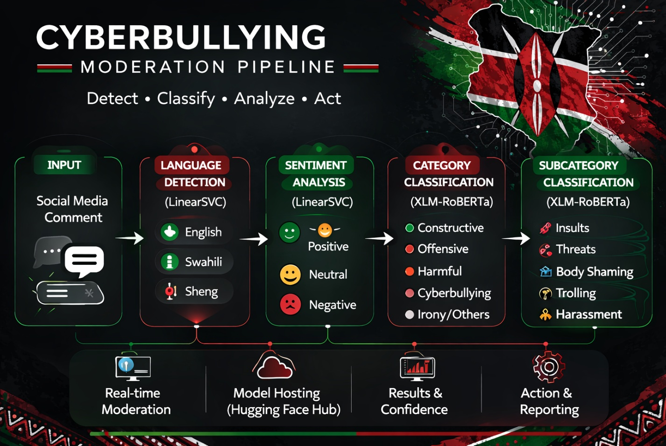
When a user submits a comment through the interface, the text is first processed, then passed through the hierarchical classification pipeline to determine the language, category, and subcategory of the comment

Model Hosting
Due to the large size of the trained transformer models, the models were hosted externally using Hugging Face Hub. Hosting the models allows them to be downloaded dynamically when the application initializes.
The approach offers several advantages:
- Reduced storage requirements for the deployed application
- Easy version control of the trained model
- Improved scalability when deploying applications to cloud environments.
The deployed application downloads the required models from Hugging Face repositories and caches them locally to minimize loading time during predictions.

6.3 User Interface
The moderation system provides dashboards that allow users to analyze comments in real time. The interface supports two moderation modes:

Single Comment Analysis
A user manually enters a comment into the text input field. Once submitted, the system processes the comments and returns the following predictions:
- Detected language
- Sentiment classification
- Comment category
- Subcategory classification
- Toxicity Level

Batch comment analysis
The system allows batch analysis of multiple comments through dataset uploads. A user can upload a CSV file containing multiple comments, and the system processes each comment through the pipeline.
The results are returned as a structured table displaying the predicted labels for each comment and a language analysis, category analysis, and sentiment analysis from the predicted comments. This allows moderators to analyze large volumes of social media data efficiently.

Model Optimization for Deployment
To improve model performance, several optimization strategies were implemented:
Model caching using Streamlit resource caching functionality to prevent models from reloading on every application run
Hierarchical classification to reduce computational complexity by activating subcategory models only when required.
External model hosting through Hugging Face reduced application size and enabled scalable deployment.

Future Deployment Improvements
Future improvements to the deployment architecture may include:
- Deploying the system as a REST API for integration with social media moderation tools
- Implementing GPU-based inference to accelerate transformer predictions
- Expanding the system to support additional social media platforms such as TikTok and Twitter
- Continuously updating the models with new slang expressions and emerging cyberbullying patterns

